**CS 131 C# - Beginner**

**HOP01B – GitHub with Visual Studio**

11/16/2019 Developed by Apiwat Chuaphan

12/26/2019 Reviewed by Kim Nguyen

Center for Information Assurance (CIAE) @City University of Seattle (CityU)

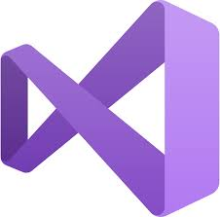 

**Before You Start**

* Version numbers may not match with the most current version at the time of writing. If given the option to choose between stable release (long-term support) or most recent, please choose the stable release rather than beta-testing version.
* This tutorial targets Windows users and MacOS users.
* There might be subtle discrepancies along the steps. Please use your best judgement while going through this cookbook style tutorial to complete each step.
* For your working directory, use your course number. This tutorial may use a different course number as an example.
* The directory path shown in screenshots may be different from yours.
* If you are not sure what to do or confused with any steps:
  1. Consult the resources listed below.
  2. If you cannot solve the problem after a few tries, ask a TA for help.

**Learning Outcomes**

Students will be able to:

* Create GitHub account
* Use Git, GitHub with Visual Studio

**Before you start**

Version control system (VCS) is created to makes it easy to store different versions of the project you are working at any time (without any fixed rules, time or rules). You can easily restore an earlier record and compare the content with the current data to find the differences. In addition, it also an effective tool to cooperate with many other people in the same project. In this module, we will learn about one of the most popular VCS which is Git and GitHub.

**Create an account on GitHub**

1. Visit <https://github.com/> and click on “Sign up for GitHub”
2. 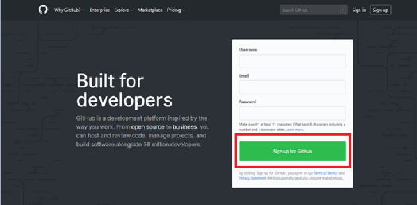
3. Filling in the form with Username, Email Address, Password and etc. It is very straightforward.
4. 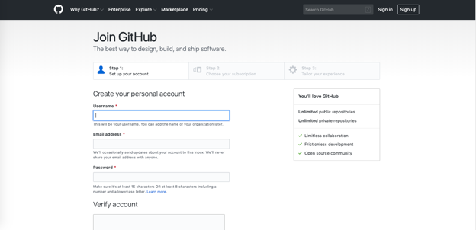
5. Click “Create Account” to proceed to next page
6. On Step 2, Choose your subscription as “Free” and click “Continue”
   1. 
7. On Step 3, just be honest and choose your options then click “Submit” or you can just click on ‘skip this step’
   1. 
8. After that, you will be asked to check your email and verify your GitHub account
9. Go to github.com and login to your GitHub account.

**Connect GitHub to Visual Studio**

1. Open **Visual Studio**.
2. Click **Continue without code**. Note that you also have the option to start the cloning experience from the welcome dialog.
3. Click **Extension > Manage Extension > GitHub Extension for Visual Studio > Download**

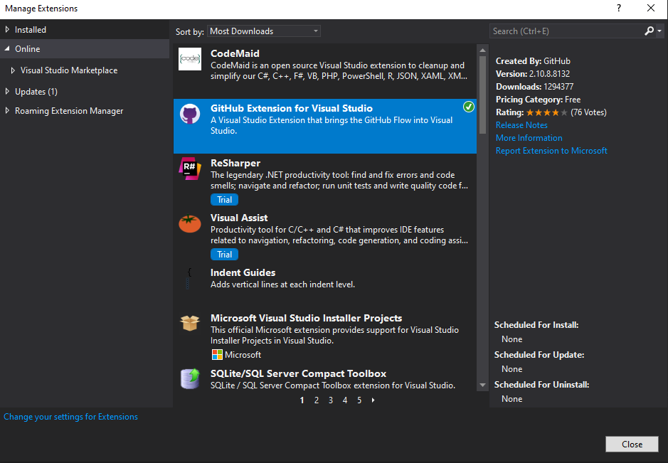

1. After downloaded, you might need to close VS to begin installing.
2. From Team **Explorer**, click the **Manage Connections** button.
3. Under **GitHub**, click **Connect**. Complete the process to sign into your GitHub account.

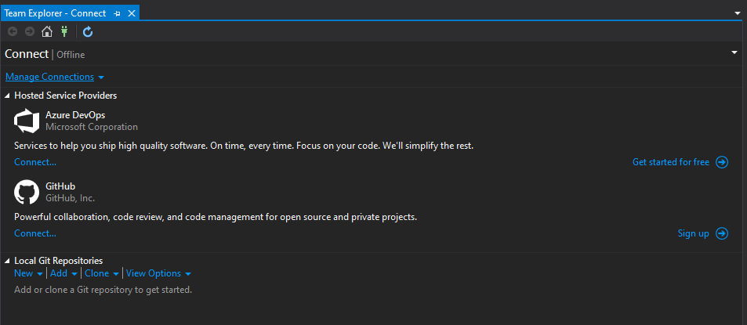

**Create a Fork on GitHub**

1. Open a web browser to the GitHub project page

<https://github.com/cityuseattle/CS131-Spring-2020>

1. Click on the "Fork" button in the upper right corner.

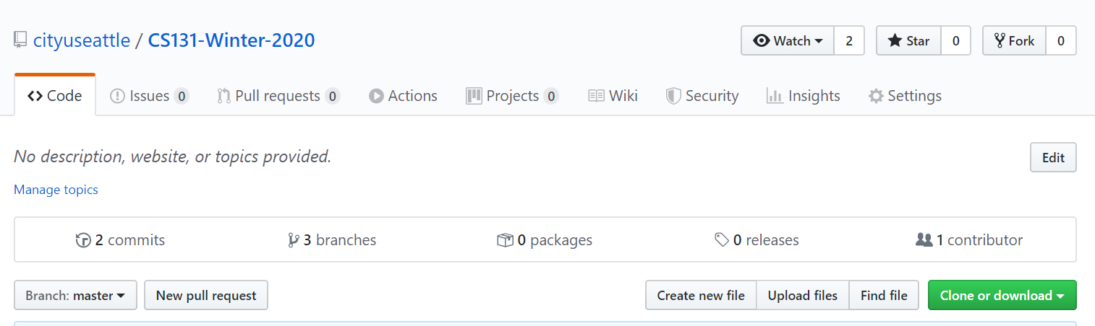

This creates a copy of the repository under your GitHub account which you have read and write access.

1. Click **Clone** under GitHub to clone your forked repository to your local machine using Visual Studio.

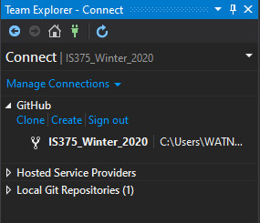

Notice that this is your own copy of the repository connected to the fork and not the main repository.

1. Type in your forked repository URL and select a path to store that repository.

**Create a local branch**

1. Click on the **Home** button > **Branches**
2. Right click on **master >** select **New Local Branch From…**

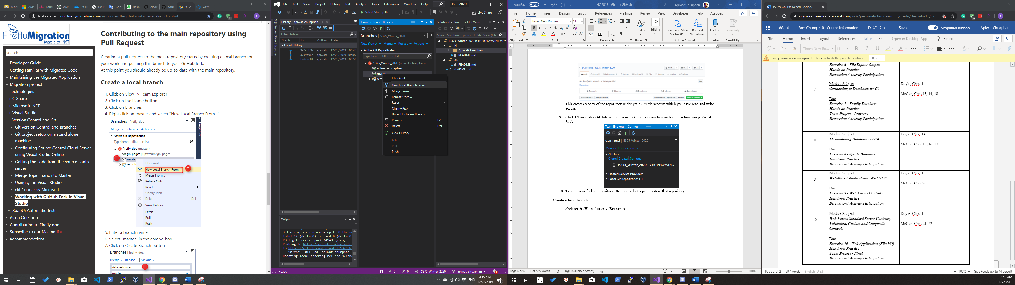

1. Type in your name (**firstname-lastname**) and select **Create Branch**

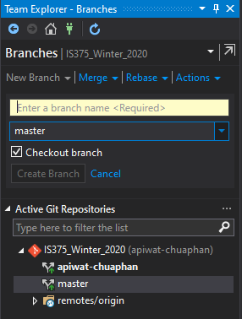

**Commit changes**

1. Click on the **Home** button > **Changes**
2. Type commit message
3. Select **Commit All and Push**

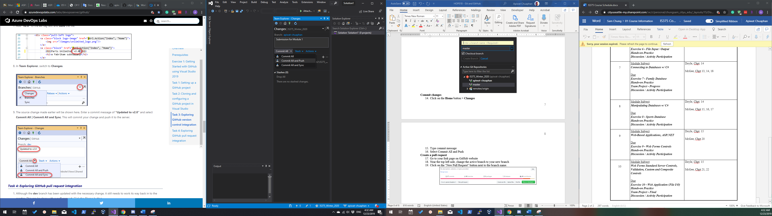

**Create a pull request**

1. Go to your fork page on GitHub website
2. Near the top left side, change the active branch to your new branch
3. Click on the "New Pull Request" button next to the branch name.

